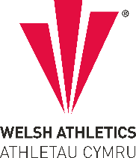
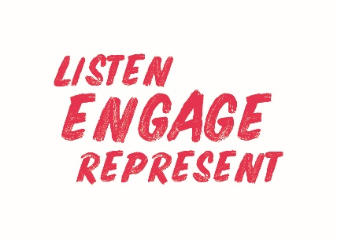
Welsh Athletics Endurance Officials Meeting Minutes
Held on the 7 February 2022
Meeting held remotely via video link

Apologies: Danielle Phillips
Papers circulated in advance:
Actions from meeting
Item Number | ACTIONS | Person responsible
4b | Zoe to contact all level 1 Endurance Officials to raise awareness of the pathway to Level 2 and to contact Level 2 to promote pathway to level 3. | ZH
5a | Create presentation for Officials Conference on the pathways for Endurance Officials | ZH
5a | Create Risk Awareness presentation for the Conference | NJ & AD

Present:,
Zoe Holloway, Paul Brooks, Nigel Jones, Christine Vorres, Jacqueline Brace,
Rhiannon Linington-Payne, Alex Donald

- Previous Minutes
The December minutes were declared as a true record.

- Declaration of Interest
None declared

- Decisions
  - The appointment of Alex to Endurance Competition Manager and the Endurance Officials Committee
Zoe welcomed Alex to the meeting and outlined some of what his role will involve. Alex will deliver an off-track programme of events and will oversee the selection of Officials for championship events. Alex plans to work closely with the committee members to make the selection of officials fairer. Nigel suggested it would be good to help develop new officials.

- Discussion
  - Matters Arising from previous minutes
None arising
  - Progression from Level 1 to Level 2 Endurance Official
Following receipt of an email requesting progression pathway for Endurance officials Zoe explained the current process to the members. It was decided this needs to be communicated to all officials. Jacqueline advised the members that it would be good to recruit more adjudicators too. Some Adjudicators were not actually officials – the process has changed since this was allowed.

- Information
  - Education
Zoe updated the members on the courses that have been requested recently
No progress on Trail and Mountain
There are courses available for Endurance Officials from UK Athletics
The Members discussed options for workshops/presentations for the Officials Conference on 6th March. The link for signing up for the conference is now live.
b. Competition Update
Alex confirmed the committee would help with the selection of key officials for championship events
Championship races are selected for 2 years
- AOB
Discussion about the criteria for picking events to use as championship races – and the lack of events further north. The question was asked if the Masters series of races could be changed next year. The chosen events have already been told that they will be championship races for 2 years.

Jacqueline told the meeting that race licence applications are now starting to come in – great that events are happening again.

It has been requested to move the meetings to the later time of 6pm. This was agreed

James Williams has been informed that the committee members are happy to take on responsibility of adjudicating event complaints – although it is anticipated that these will be few and far between.
Meeting ended at 6.15pm
Minutes written by Christine Vorres – 7 February 2022
Next meeting 11 April 6pm
Dates for 2022 meetings:
11 April, 6 June, 8 Aug, 10 Oct and 5 Dec.
Dates in line with General Council meetings.

